| IUT_LOGOIUT_LOGO  **ISLAMIC UNIVERSITY OF TECHNOLOGY**  **Course Outline and Course Plan** |
| --- |

| **Name of the Teacher** | Md. Nazmul Haque | | | **Position** | | Assistant Professor | | |
| --- | --- | --- | --- | --- | --- | --- | --- | --- |
| **Department** | Computer Science and Engineering | | | **Programme** | | B. Sc. in SWE | | |
| **Course Code** | SWE 4637 | | | **Course Title** | | Web and Mobile Application Development. | | |
| **Academic Year** | 2022-2023 | | | **Semester** | | Summer (6th) | | |
| **Contact Hours** | 3.0 | | | **Credit Hours** | | 3.0 | | |
| **Text books and Reference books (if any)** | 1. FullStack React  2. Learning React  3. Learning React Native | | | **Authors of the books** | | 1. Anthony Accomazzo  2. Alex Banks, Eve Porcello  3. Bonnie Eisenman | | |
| **Prerequisites**  **(If any)** | SWE 4537: Server programming | | | Curriculum Requirement | | Compulsory | | |
| **Teaching Methods/**  **Approaches** | accept, approve, box, check, mark, ok, success, tested, tick, valid, validation, yes icon **Lecture** | **Group discussion** | | | **Demonstration** | | | accept, approve, box, check, mark, ok, success, tested, tick, valid, validation, yes icon**Problem solving** |
| **Project** | **Others: Presentation by Students** | | | | | | |
| **Teaching aids** | accept, approve, box, check, mark, ok, success, tested, tick, valid, validation, yes icon**Multi-media** | | **OHP** | | accept, approve, box, check, mark, ok, success, tested, tick, valid, validation, yes icon**Board and Marker** | | **Others** | |

| **Course Assessment Method** | | | | | | | | |
| --- | --- | --- | --- | --- | --- | --- | --- | --- |
| **Attendance (10%)** | **Quiz 15% of Total Marks (Best 3 out of 4)** | | | | | | **Mid Semester (25%)** | **Semester Final (50%)** |
| **Evaluate based on the participation in the class** | **1st Quiz** | **2nd Quiz** | **3rd Quiz** | **4th Quiz** | **Others** | | **Week/Date** | **Week/Date** |
| **Week/Date** | **Week/Date** | **Week/Date** | **Week/Date** | **Assignment** | **Homework** |
| **3rd Week** | **6th Week** | **10th Week** | **13th Week** | **Will be given accordingly** | **Will be given accordingly** | **As per schedule of IUT** | **As per Schedule of IUT** |

| **Course Contents and Objectives** | **Contents**  **Web Application Development:** Frontend development with React JS.  **React JS:** Forms and User Input, React Hooks, State Management  **Next JS:** a React JS framework. Full stack development  **Data Storage for Web Platform:** Local and Online Server Storage  **Cross Platform Mobile App Development:** Android App Development  **React Native:** Reusable Components Navigation, State Management, User Interface, Handling Notifications  **Data Storage for Mobile Platform:** Local Storage, Firebase  **Network Activities from Mobile App:** Using Outside API, Handling HTTP requests  **Communication with the Outside World:** API Requests  **Objectives**  The course aims to provide the student with:   * An understanding of the basic components and structures in web application development with React JS. * Developing a web app that handles user inputs, data storage, network communications, and inputs and notification handling * An understanding of the basic components and structures in mobile application development. * An in-depth understanding of the React Native components, navigation, state management, and user. * Developing a firm grip on the Cross-Platform App Features, Using Outside API and Fundamentals required for making Mobile Applications |
| --- | --- |
| **Course Outcomes** | **CO1 - Understand** the concept of front end (HTML, CSS, JS) with ReactJS and nextJS, Back End (NodeJS, ExpressJS), Database (MongoDB, MySQL), and Android Mobile application.  **CO2 - Analyze and explain** the Data Flow, API Functionalities, and User Interface in Web and mobile Platform  **CO3 – Recommend** solutions to real-life software projects and design custom hooks using the techniques of React and Android mobile applications languages for web and mobile applications, respectively, with Database (MongoDB, MySQL). |

| **Weekly plan for course content** | | |
| --- | --- | --- |
| **Weeks** | **Topics** | **Task/Reading** |
| **1** | Introduction to HTML, CSS, JavaScript |  |
| **2** | React introduction, Building Components with React  Props and State Management in React Components  Handling User Inputs and Forms  Making API Request from React | Quiz 1 - CO1, CO2 |
| **3** |
| **4** | Understanding React Hooks  Data Storage for React |  |
| **5** | React Context API |  |
| **6** | Deploying a React App | Quiz 2 – CO1, CO2 |
| **7** | Next JS, a framework of React JS |  |
|  | MID Semester Examination | MID - CO1,CO2,CO3 |
| **8** | Introduction to NodeJS, ExpressJS |  |
|
| **9** | Authorization using JWT, Routing, API design using ExpressJS | Quiz 3 – CO2, CO3 |
| **11** | Introduction to Android Mobile App development SDK, API, Version, and tools |  |
| **12** |  |
| **13** | Activities, services, broadcasts, intents, and UI layouts of Android |  |
| **14** | Android permission management, data storage, cloud computation and storage mechanism, challenges, and design guidelines | Quiz 4 – CO4,CO5 |
| **15** |  |
|  | Semester Final Examination | Final – CO3, CO4, CO5 |

**Mapping of COs and POs**

| Course Outcome (CO) | Blooms Taxonomy | Program Outcomes (POs) | | | | | | | | | | | |
| --- | --- | --- | --- | --- | --- | --- | --- | --- | --- | --- | --- | --- | --- |
| 1 | 2 | 3 | 4 | 5 | 6 | 7 | 8 | 9 | 10 | 11 | 12 |
| **CO1 - Understand** the concept of front end (HTML, CSS, JS) with ReactJS and nextJS, Back End (NodeJS, ExpressJS), Database (MongoDB, MySQL), and Android Mobile application. | C2 | √ |  |  |  |  |  |  |  |  |  |  |  |
| **CO2 Analyze and Explain** the Data Flow, API Functionalities, and User Interface in Web and Mobile Platform. | C3 | √ | √ |  |  |  |  |  |  |  |  |  |  |
| **CO3 – Recommend** solutions to real-life software projects and design custom hooks using the techniques of React and Android mobile applications languages for web and mobile applications, respectively, with Database (MongoDB, MySQL). | C4 |  |  | √ |  |  |  |  |  |  |  |  |  |

**Mapping of Course Outcomes (COs) and Program Outcomes (POs) and Evaluation Methods**

| **Assessment Method** | **Marks** | Mark distributions (as %) on COs and POs | | |
| --- | --- | --- | --- | --- |
| CO1 | CO2 | CO3 |
| PO1 | PO2 | PO3 |
| Quiz 1/Quiz 2/Quiz 3/Quiz 4 | 30% | 15% | 15% |  |
| Attendance (Class Participation) | 10% | 10% | - | - |
| Midterm Exam. | 25% | 10% | 15% | - |
| Final Exam. | 25% | 5% | 5% | 15% |
| VIVA | 10% | 5% | 5% |  |
| Total | 100% | 45% | 40% | 15% |

**Program Outcomes (POs : PO1 ~ PO12)**

| **PO No.** | **Program Outcomes (POs)** |
| --- | --- |
| **Students graduating from the Bachelor of Science in Software Engineering program, upon graduation students will have the ability to:** |
| PO1 | **Engineering Knowledge:** Apply knowledge of mathematics, natural science, engineering fundamentals and system fundamentals, software development, networking & communication, and information assurance & security to the solution of complex engineering problems in computer science and engineering. |
| PO2 | **Problem Analysis:** Ability to identify, formulate and analyze complex Software Engineering problems in the areas of hardware, software, theoretical Computer Science and applications to reach significant conclusions by applying Mathematics, Natural sciences, Software Engineering principles. |
| PO3 | **Design/ Development of Solutions:** Design solutions for complex computer science and engineering problems and design systems, components or processes that meet specified needs with appropriate consideration for public health and safety, cultural, societal, and environmental considerations. |
| PO4 | **Investigation:** Ability to use research based knowledge and research methods to perform literature survey, design experiments for complex problems in designing, developing and maintaining a computing system, collect data from the experimental outcome, analyze and interpret valid/interesting patterns and conclusions from the data points. |
| PO5 | **Modern Tool Usage:** Ability to create, select and apply state of the art tools and techniques in designing, developing and testing a computing system or its component. |
| PO6 | **The Engineer and Society:** Apply reasoning informed by contextual knowledge to assess societal, health, safety, legal and cultural issues and the consequent responsibilities relevant to professional engineering practice in system development and solutions to complex engineering problems related to system fundamentals, software development, networking & communication, and information assurance & security. |
| PO7 | **Environment and Sustainability:** Apply reasoning informed by contextual knowledge to assess societal, health, safety, legal and cultural issues and the consequent responsibilities relevant to professional engineering practice in system development and solutions to complex engineering problems related to system fundamentals, software development, networking & communication, and information assurance & security. |
| PO8 | **Ethics:** Apply ethical principles and commit to professional ethics and responsibilities and norms of software engineering practice. |
| PO9 | **Individual Work and Teamwork:** Ability to function as an individual and as a team player or leader in multidisciplinary teams and strive towards achieving a common goal. |
| PO10 | **Communication:** Communicate effectively on complex engineering activities with the engineering community and with society at large, such as being able to comprehend and write effective reports and design documentation, make effective presentations, and give and receive clear instructions. |
| PO11 | **Project Management and Finance:** Demonstrate knowledge and understanding of engineering management principles and economic decision making and apply these to one’s own work, as a member and leader in a team, to manage projects and in multidisciplinary environments. |
| PO12 | **Life-long learning:** Recognize the need for, and have the preparation and ability to engage in independent and lifelong learning in the broadest context of technological change. |

**K**

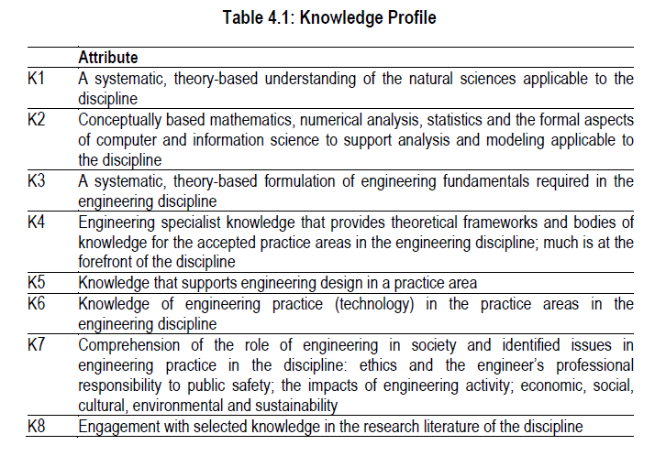

**P**

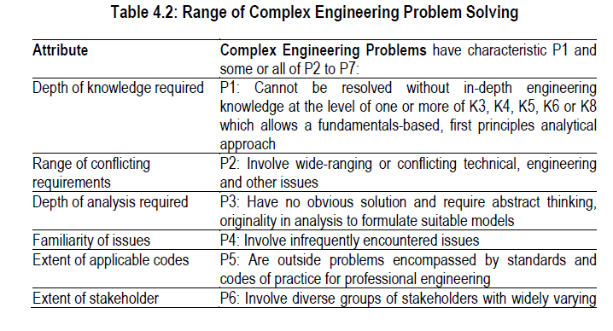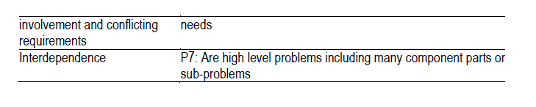

**A**

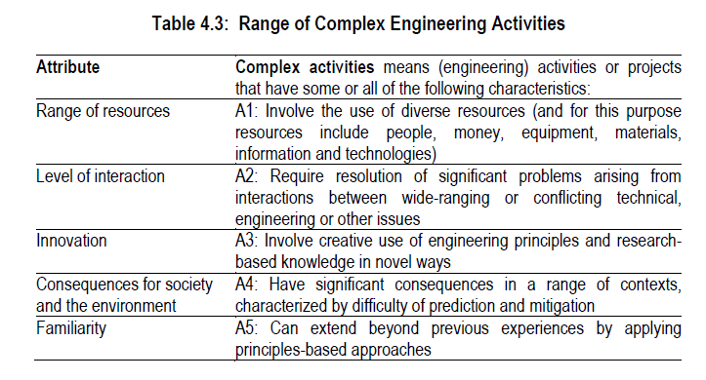

**Grading Policy**

| **Numeric Grade** | **Letter Grade** | **Grade Point** |
| --- | --- | --- |
|  |  |  |
| 80% and above | A+ | 4.00 |
| 75% to less than 80% | A | 3.75 |
| 70% to less than 75% | A- | 3.50 |
| 65% to less than 70% | B+ | 3.25 |
| 60% to less than 65% | B | 3.00 |
| 55% to less than 60% | B- | 2.75 |
| 50% to less than 55% | C+ | 2.50 |
| 45% to less than 50% | C | 2.25 |
| 40% to less than 45% | D | 2.00 |
| Less than 40% | F | 0.00 |

**Class Schedule**

| **Day** | **Section 1** | **Section 2** |
| --- | --- | --- |
| Tuesday | 10:30 AM – 11:45 AM | 08:00 AM – 09:15 AM |
| Thursday | 08:00 AM – 09:15 AM | 03:45 PM – 05:00 PM |

**Student’s consulting hour:** Email for appointment

**Course Teacher contact details:**

Md. Nazmul Haque

Assistant Professor

Department of Computer Science and Engineering (CSE)

Islamic University of Technology (IUT)

Board Bazar, Gazipur-1704, Bangladesh.

E-mail: [nazmul.haque@iut-dhaka.edu](mailto:nazmul.haque@iut-dhaka.edu)

Contact: +8801521219023, +8801786870220